
Request Core/vCPU Increase in Azure Subscription
2/10/2021

Cognizant Microsoft Business Group
20 North Wacker Drive #530
Chicago, IL 60606

Notice of Confidentiality ©2021 Cognizant Microsoft Business Group All rights reserved.

IS SUBJECT TO THE TERMS OF THE COGNIZANT MICROSOFT BUSINESS GROUP NON-DISCLOSURE AGREEMENT. NEITHER THIS DOCUMENT NOR ITS CONTENTS MAY BE REVEALED OR DISCLOSED TO UNAUTHORIZED PERSONS OR SENT OUTSIDE THE AFOREMENTIONED COMPANY WITHOUT PRIOR PERMISSION FROM COGNIZANT MICROSOFT BUSINESS GROUP
Table of Contents
Summary 3
Overview 3
Scenario #1 3
Scenario #2 3
Request via Azure portal 4

Summary
The purpose of this document is to show the process of requesting a core increase on an Azure subscription. This guide is going to give an overview with brief scenarios where you can plan ahead, as well as give you an example of a failed deployment, where the same action can be taken for both.

Overview
When you are attempting to create a new VM, or failover a group of VM’s with Azure Site Recovery, the attempt might fail due to meeting or exceeding subscription limits. Limits on the core count are per subscription/region and VM SKU family. You can find limits in detail here under Virtual Machines limits - Azure Resource Manager.

Scenario #1
A new project has been kicked off and planning has started with the customer. In an application discovery call, the architect and CMC lead identify that there are multiple instances of the same application in multiple environments. The project team recommends using a Standard_D4s_v3 VM SKU. The project team has identified 1000+ VMs that will use D-series machines; to avoid a slowdown in the middle of the project, the architect has tasked a CMC engineer to request a core count increase in the East US 2 Azure Region through Microsoft Support.

Scenario #2
A newly onboarded CMC engineer has completed training and has been added as a team member to an ongoing project. The new engineer’s first task is to conduct failover testing, but runs into an error that looks like this:
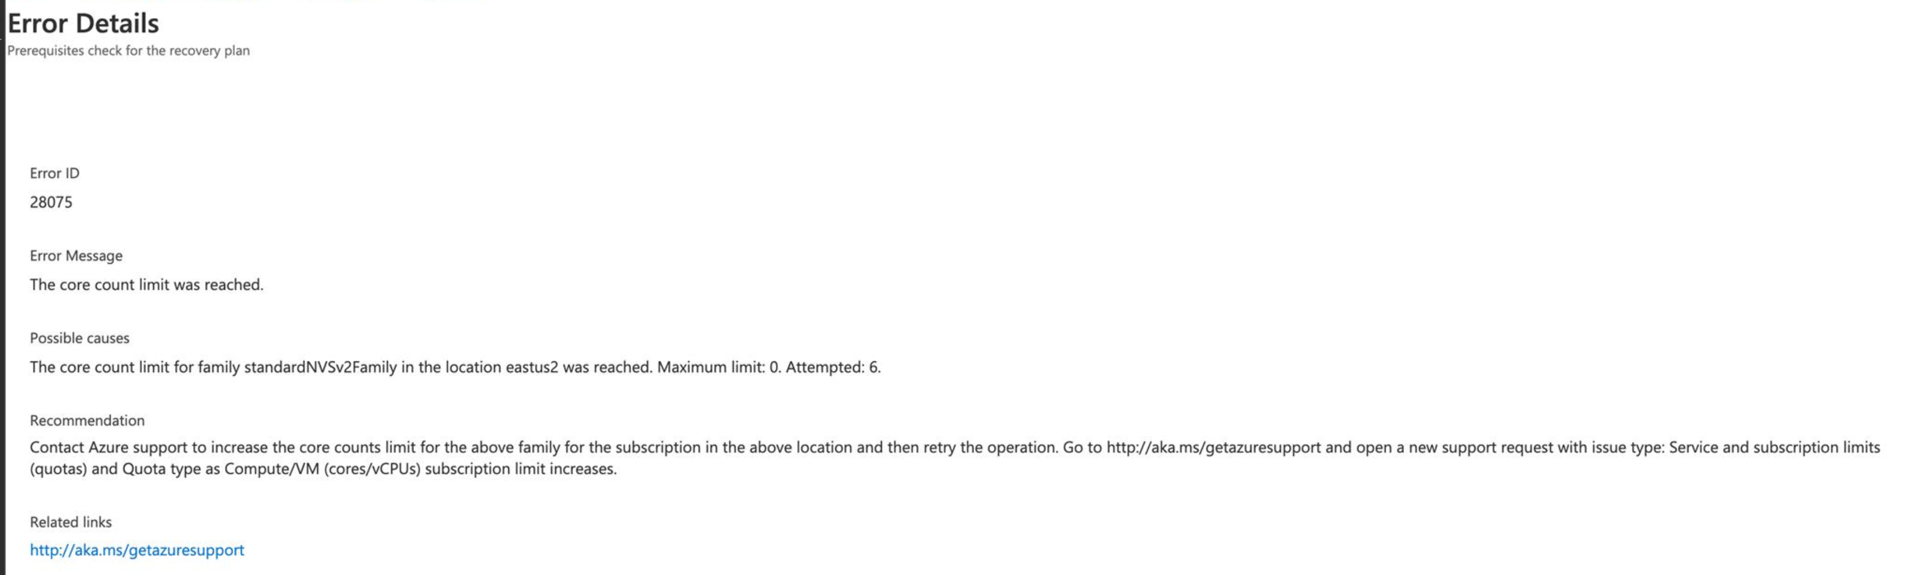
The new engineer asks his teammates for help and they recommend requesting a core count increase through Microsoft Support.

Request via Azure portal
- Click ? on the top right side of the Azure Portal and then click Help + Support
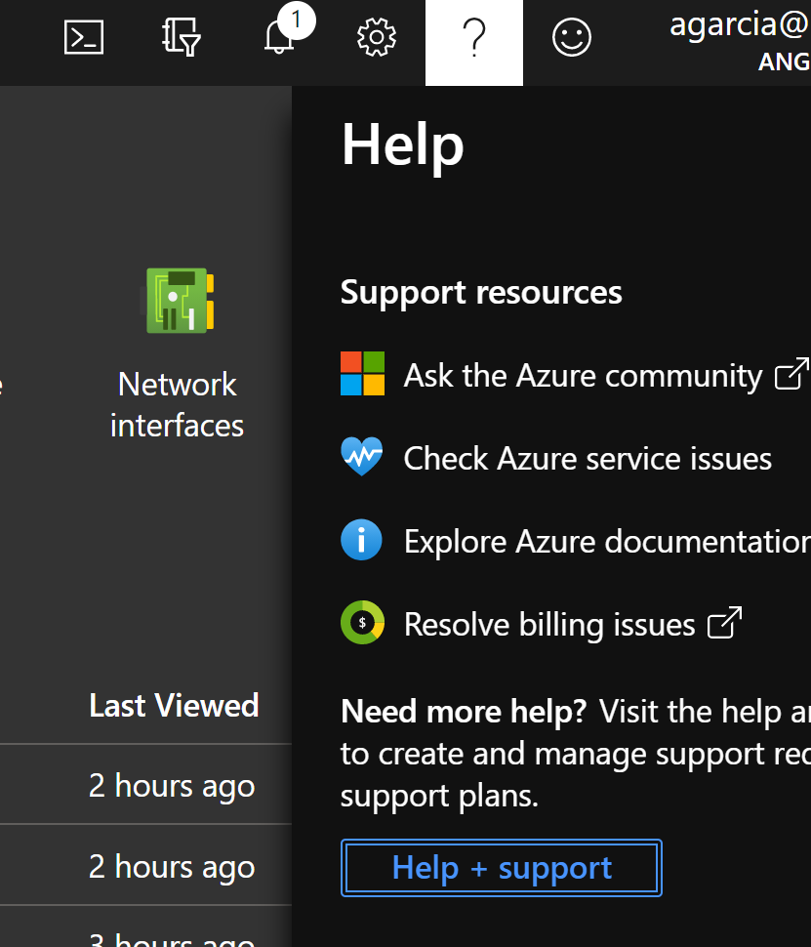
- On the Help+Support page, click +New Support Request
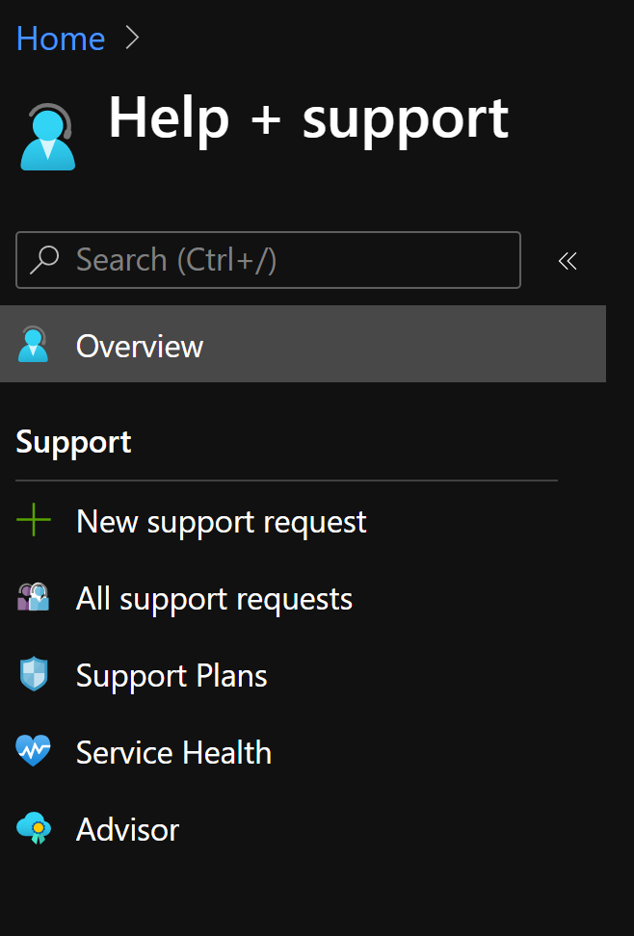
- On the Basics page
  - Click the Issue Type drop-down and select Service and Subscription Limits (quotas)
  - Click the Subscription drop-down and select your target subscription
  - Click the Quota Type drop-down and select Compute-VM (cores-vCPUs) subscription limit increases
  - Click Next: Solutions at the bottom of the page
*Note: Clicking Next at this step will skip the Solutions page and take you to the Details page.
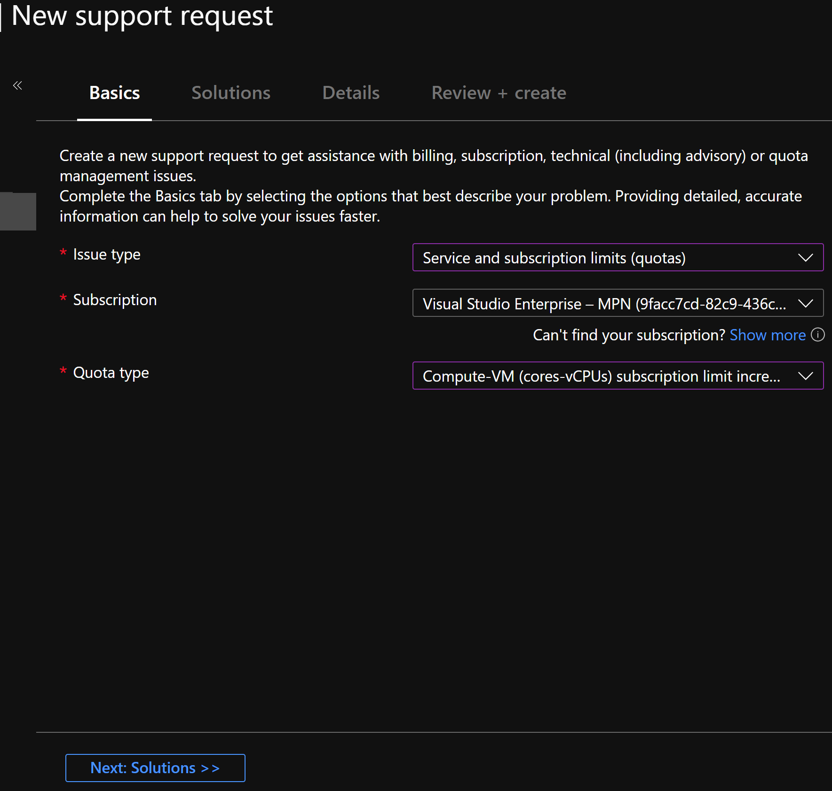
- On the Details page
  - Under Problem Details, select Enter Details
    - Deployment Model – Select Resource Manager
    - Locations – Select the Azure Regions you are requesting an increase for
    - Types – Select Standard
    - Standard – Select VM Family you would like to increase quota for
    - Manually enter a new vCPU limit that you would like
    - Click Save and Continue
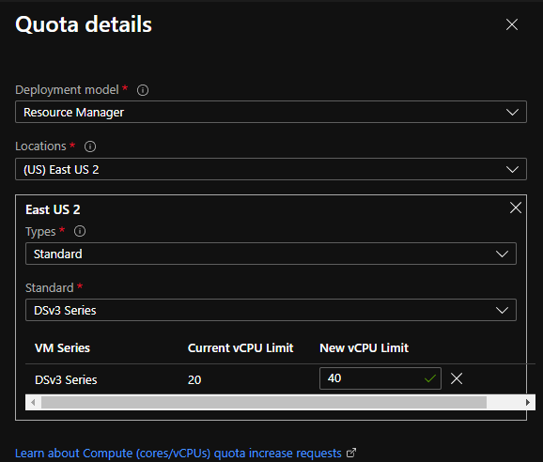
  - Under Support Method
    - Select Severity based on your individual situation.
    - Select your Preferred Contact Method
    - Select Your Availability – depending on the support tier in the customer tenant you can select 24x7 or Business Hours
    - Select your Support Language
  - Under Contact Info
    - Enter your details to be contacted by Microsoft Support
    - Click Next: Review+Create
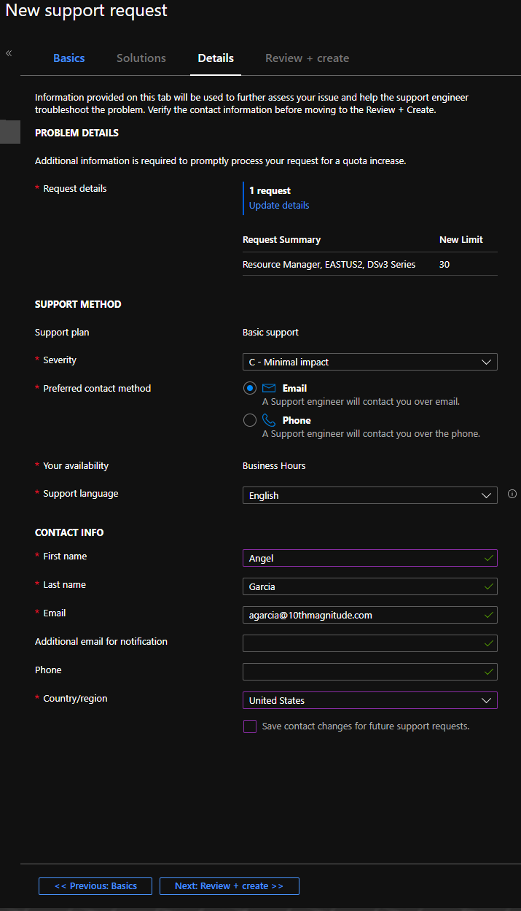

- On the Review + Create page, ensure all of the information you’ve entered is correct and click Create
